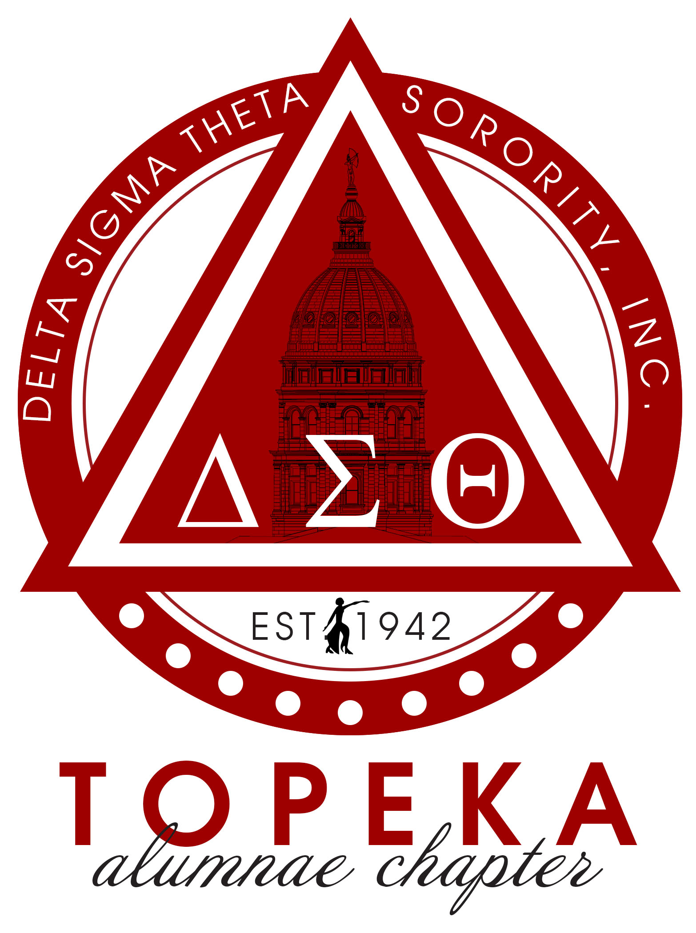
Delta Sigma Theta Sorority, Inc.

February 20, 2021

Dear Student:

Delta Sigma Theta Sorority, Inc. has established a scholarship fund for African-American female high school seniors who wish to enroll in a four-year degree program, on a full-time basis, at an accredited college. In order to qualify for this scholarship, you must live in Shawnee or Douglas County, attend a Public School (USD 501, USD 437, USD 450 and USD 345) or parochial school. You must also be graduating this spring with a 3.0 GPA or better and must demonstrate community service. Community service may include civic, church or related activities.

Enclosed, please find our scholarship application form. Application instructions are as follows:

Instructions:
- Your completed application must be typewritten or printed legibly.

- Your application must include three (3) letters of reference from individuals familiar with your academic, community service and personal background.

- Your completed application packet must include those three letters of reference, current transcript and financial statement and must be RECEIVED BY OUR OFFICE BY SATURDAY, April 3, 2021.

- Mail to:
Delta Sigma Theta Sorority Inc.
Topeka Alumnae Chapter
P.O. Box 4917
Topeka, Kansas 66604

*Please note that incomplete or late applications will render you ineligible for consideration for this scholarship. A Scholarship Committee, composed of representatives of Delta Sigma Theta Sorority, Inc. will review each application. A final determination will be made by April 10, 2021. If you have any questions about the scholarship or application requirements, feel free to call me at (785) 220-6220 or you may e-mail me at sluggersmom55@gmail.com.

Sincerely,
Valerie Patterson Tami E. Farr Smith
Scholarship Committee, Chairperson President

